Brazil Monetary Environment Analysis
WARDOGS (TEAM 5)
GBK-344-115-Global Business Environment

July 3 2017

Brazil has a city that is significant regarding finance and also for its economy. In fact, the city itself is among top 10 richest cities around the world. The city is known as Sao Paulo. Also, shortly, the city is expected to be doing well regarding its economy. The city growth regarding economy has been affected by factors such as its location; therefore, the city can attract a significant number of investors (Montgomery & Stern, 2013). The city also hosts some international events; it also receives a significant number of tourists in a year. Therefore, the city can accrue a lot of profit, therefore, improving Brazil economy.
Brazilian domestic market bond about the GDP is minimal. However, from the year 1994, the bond market in Brazil has been increasing at a significant rate. The rate at which the bond market has been increasing can be related to some positive factors such as the economy is stable (de Carvalho & Sampaio, 2017). The government also has ensured a regulatory environment administering security markets. Brazil has a total 26% of its total bonds belonging to the private sector and 27% belonging to the market that is currently emerging.
The Brazil stock market has been increasing at a faster rate in comparison to the global market. There are some of the measures that the country is set to support its recovery. It has reduced its tare of interest and therefore, shortly, the stock of Brazil about its economy is likely to rise. Also, its equities are continuing to rise and post a ~39% on the Bovespa; Brazil stock index. The figures are about the stock fall of 13% in the year 2015 (Ahmed & Coulibaly & Zlate, 2017).

The current exchange rate between the Brazil Real (BRL) and the U.S. dollar (USD) as of July 1, 2017 is 1.00 BRL to .30 USD. (X-Rate, 2017)
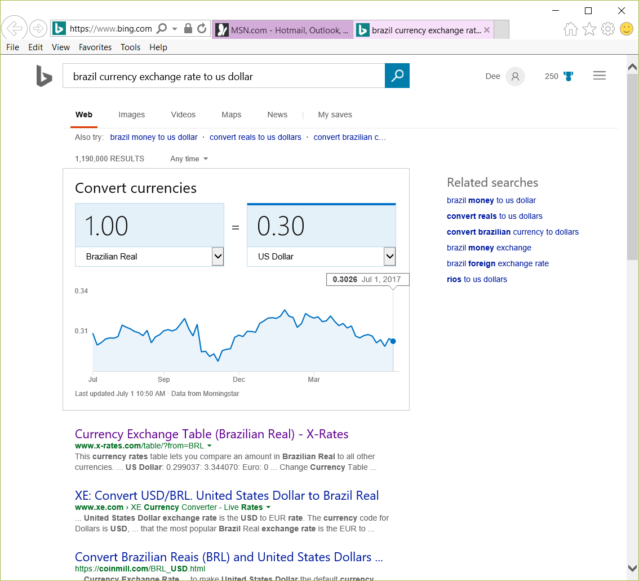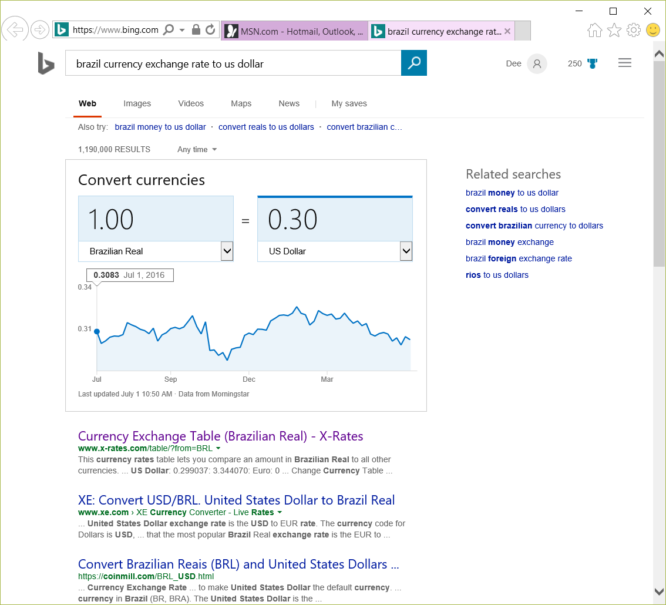

1.00 USD = 3.31 BRL
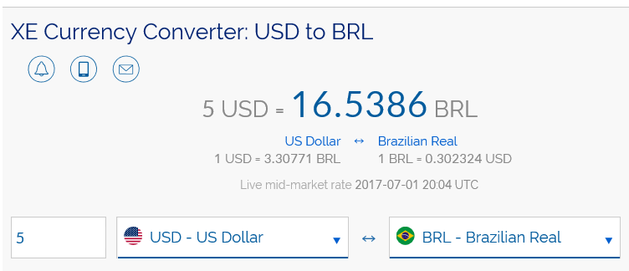 (XE , 2017)
Therefore, if you have 5.00 USD and wanted to exchange to BRL you would be able to afford 16.54 BRL.

The Brazilian Exchange rate in the U.S. dollars are constantly changing. Brazil is a country that is holding up to high standard when it comes to the U.S. dollar. Although it is not at the same rate, it is closer than any figure in its surrounding countries located in South America. “Despite recent appreciation, the Brazilian Real stands at record high levels against the USD, and even considering the situation of Brazil, these levels find little support on fundamental grounds,” (Esteves, 2016).
As of June 30, 2017, the exchange rate was one Brazilian Real (dollar) was worth thirty cents USD. Below is a chart of the exchange rate from one year ago beginning July, 2016 and up to the month of June, 2017. The value of $1 USD to Brazilian Real on June 30, 2017 was 3.21 and the value of $1 USD to Brazilian Real in 30 June, 2017 is 3.32. With the calculation described on Appendix in Chapter 9, We calculate (1/3.21= 0.316) and (1/3.32= 0.30). Now we subtract both answer and divide it into 0.30 then multiply it by 100 and we will receive the amount of 5%.
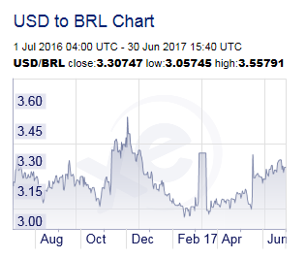
There are many restrictions on the exchange of Brazil’s currency. In Brazil, accounts can only be kept in Brazilian Reais. For importers, alike in order to remit funds to a person in the United States, for example, the importer has to purchase the foreign funds through a “contract at the bank authorized by the Brazilian Central Bank” (E, Braxado). Also, the exchange rate and fees are decided upon between the purchaser of the currency and the bank. The federal agency that is entrusted to the National Monetary Council is the Brazilian Central Bank. The National Monetary Council has policies to keep their financial system stable as well as control of foreign capital flows. Over the course of Brazil’s history its country has had stringent exchange controls. Limitations on foreign accounts and currency have been imposed. Going back to the sterling devaluation of 1931, the Decree 20531 recognized the need to centralize their foreign exchange in order to keep the country’s currency stable. The Bank of Brazil implemented for a way to purchase the currencies safely and exchange foreign values. The government also imposes restriction on conversions and remittances which affects the time and amount of payment we receive. “Although dividend payments related to profits obtained subsequent to April 28, 2006 are not subject to income tax, if the sum of repatriated capital and invested capital exceeds the investment amount registered with the Brazilian Central Bank, repatriated capital is subject to capital gains tax of 15 percent” (CRESY)

References
Ahmed, S., Coulibaly, B., & Zlate, A. (2017). International financial spillovers to emerging market economies: How important are economic fundamentals? Journal of International Money and Finance.
de Almeida, A. and Frascaroli, B. (2014). Financial Crisis of 2007-2009 and Stress Test with Structural Changes for the Brazilian Financial Market. Journal of International Business and Economics, 2(3).
Edwards, S. and Garcia, M. (2008). Financial markets volatility and performance in emerging markets. Chicago: University of Chicago Press.
Hagemann, G. (2016). Financial Reporting Quality in Emerging Economies. Frankfurt a.M.: Peter Lang GmbH, Internationaler Verlag der Wissenschaften.
Montgomery, M. R., Stren, R., Cohen, B., & Reed, H. E. (2013). Cities transformed: demographic change and its implications in the developing world. Routledge.

Stryzhychenko, K. (2014). ADAPTATION OF UKRAINIAN FINANCIAL MARKET TO THE FOREIGN FINANCIAL MARKET. Corporate Ownership and Control, 11(4
Esteves, A. T. (2016, February 14). Seeking Alpha. Retrieved from Is the BRL/USD Exchange Rate Reaching A Turning Point?: https://seekingalpha.com/article/3895096-brl-usd-exchange-rate-reaching-turning-point
XE . (2017, July 1). Retrieved from XE Currancy Converter: http://www.xe.com/currencyconverter/convert/?Amount=5&From=USD&To=BRL
X-Rate. (2017, July 1). X-Rate. Retrieved from X-Rate.com: http://www.x-rates.com/table/?from=BRL&amount=1

Braxado, Edson, comp. "The George Washington University IBI." Brazilian Foreign Exchange Controls 2003rd ser. Fall (2003): 1-71. Brazil - Foreign Exchange Controls | Privacy Shield. Oct.-Nov. 2003. Web. 03 July 2017.
http://www.wikinvest.com/stock/Cresud_S.A.C.I.F._y_A._(CRESY)/Brazilian_Government
- Does it have a city that is an important financial center? What volume of bonds is traded on the country’s bond market? How has the stock market(s) performed over the past year? Lionel
- What is the current exchange rate between its currency and the U.S. dollars as of the beginning of this month? Use the country's currency as the base currency to report a direct quote of the country's currency. Demetrias
  - What is the percentage of change in the country's currency exchange rate with the U.S dollars over one month and one year period? Reference the Appendix in Chapter 9 for the calculation of the percent change in exchange rates. Show the calculation in your assignment submission.Rico
  - Is there any restriction on the exchange of the nation’s currency? Kenneth

